How are podcasts **actually** being used?

Many things you may already be encountering in your day-to-day life, that people are calling podcasts, might not actually be “real” podcasts. This is happening a lot more lately as podcasting finds its place in the world. This identity crisis is not unusual for a “teenage technology” and a teenager it is as its only been around since 2004 (when it was originally known as audio blogging). As you can see from the Google search analysis below, interest in podcasts has **doubled** over the past year or so.

What you are most likely to be encountering as a “podcast” is your favourite radio DJ telling you to listen to their previous shows on their website. The “true” podcasters of the world will be shuddering to hear this as these radio stations and DJs are simply using podcast platforms to manage their archives.

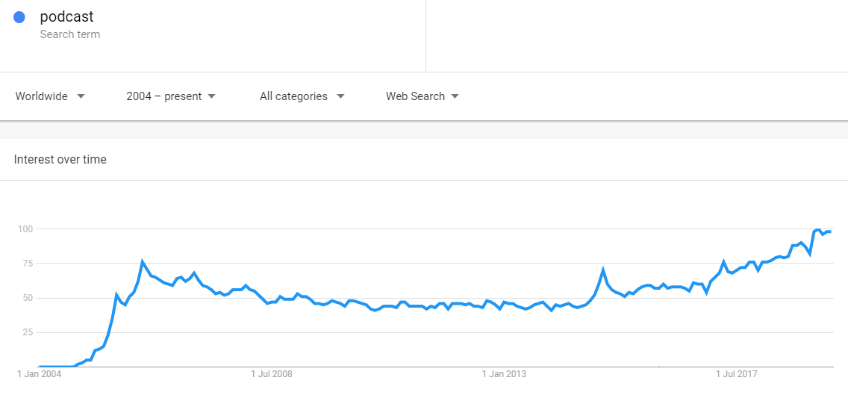

|  |  |  |
| --- | --- | --- |
| Radio Show Archives  As described above | Syndicated Radio Programming  Grounded | FAQs Frequently Asked Questions  Kip McGrath |
| Thought Leadership  On Change | Talent Showcase / Show Reels  Andy Klee | Staff Communication  ????? |
| Conferences (pre- and post-) ????? | Academic White Papers  ????? | Strategic Programming What’s The Point? |
| Entertainment Weekend Party | Book Serialisation Garage Band | Staff Training ????? |
| Deep Dive Conversations Lift As You Rise | Meditation / Spiritualism Emotion in Motion | Group Communication  WiMSA |
| Story Telling  S-Town |  |  |